ThermoBrite®

Slide Denaturation/Hybridization System

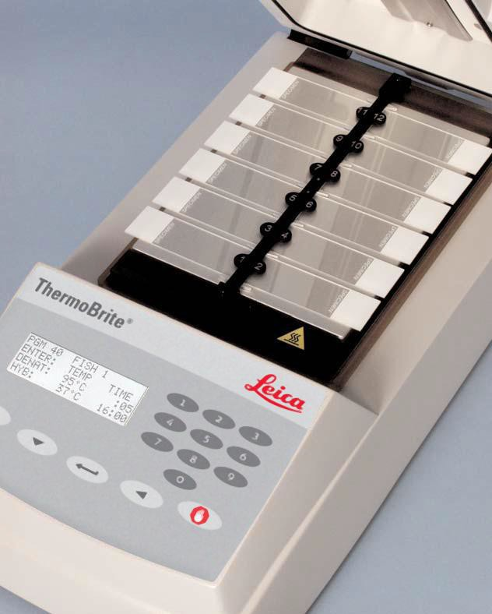

Operator’s Manual

Operator’s Manual

ThermoBrite®

Model Number S500
For in-vitro diagnostic use

3800-004852-001 - ThermoBrite Slide Denaturation/Hybridization System 120V 3800-004852-002 - ThermoBrite Slide Denaturation/Hybridization System 240V 3800-004970-001 - Humidity Card, 10pk
REF
REF
REF
REF

3800-006418-001 - ThermoBrite Temperature Verification Kit

ThermoBrite is a registered trademark.

Copyright 2013 Leica Biosystems - All Rights Reserved

Table of Contents
How to use this manual 3 Cautions and Warnings 3 Symbols and Definitions 5 Leica Biosystems Contact Information 6 Authorized European Representative 6 Manufacturer 6 Section 1 7 Warranty 7 Section 2 9 Unpacking and Installation 9 Inspect Packaging 9 Verify Contents 9 Installation Instructions 9 Section 3 11 System Overview 11 Principle and Intended Use 11 Keypad 11 Keypad Symbols and Definitions 12 Display Abbreviations 13 Audible Indicators - NORMAL 13 Section 4 14 Operating Instructions 14 Opening and Closing the Lid 14 Turning Unit On 14 Run a Program 15 Abort Program in Process 18 Slide Installation 19 Humidity Cards 19

Section 5 21
Programming 21 Overview 21 Predefined Limits 22 Creating a Denaturation and Hybridization Program (Denat & Hyb) 22 Creating a Hybridization Only Program (Hyb Only) 23 Creating a Fixed Temperature Program (Fixed Temp) 24 Editing a Program 25 Section 6 26 Maintenance 26 Overview 26 Cleaning 26 Temperature Verification 27 Service 28 Troubleshooting Guide 30 Audible Indicators - ERROR 31 Error Messages 31 Section 7 35 Specifications 35 References 36

How to use this manual
This manual along with information contained on product labels should provide you with all the information you need to operate and maintain the ThermoBrite.

Intended Purpose
ThermoBrite provides temperature control for on-board denaturation and/or hybridization for FISH testing of specimens mounted on microscope slides. Microscope slides subsequently undergo interpretation by a qualified healthcare professional to aid diagnosis.

Detection/Measurement
ThermoBrite does not detect or measure an analyte or marker. ThermoBrite provides temperature control for on-board denaturation and/or hybridization for specimens mounted on microscope slides.

Product Function
ThermoBrite is an aid to diagnosis. Microscope slides that are exposed to FISH testing on the ThermoBrite undergo interpretation by a qualified healthcare professional.

Specific Information to be Provided
ThermoBrite is not intended for the detection, definition or differentiation of a specific disorder, condition or risk factor. ThermoBrite is intended to provide temperature control for on-board denaturation and/or hybridization for FISH testing of tissue and cellular specimens for the subsequent application of specific diagnostic techniques that when evaluated by a trained pathologist may provide valuable data that are useful in the assessment of various genes or portions of genes. This data alongside other information such as the patients’ medical history, physical condition, as well as results from other medical testing is all considered when rendering a medical diagnosis.

Automation
ThermoBrite is a semi-automated instrument that allows for the end user to define the protocols used on the instrument.

Qualitative/Quantitative
ThermoBrite is not used for the detection of a specific analyte or marker.

Specimen Type
ThermoBrite is intended for use with human tissue or cellular specimens.

Testing Population
ThermoBrite does not target a specific patient group and is intended for use by qualified laboratory personnel or designee.

Intended User
ThermoBrite is intended for use by qualified laboratory personnel or designee.

Cautions and Warnings appear in boxes with symbols to the left of the text. Notes also appear in boxes to highlight information.

Cautions and Warnings
A WARNING is a statement that alerts the user to the possibility of injury, death, or other serious adverse reactions associated with the use or misuse of the instrument.
A CAUTION is a statement that alerts the user to the possibility of a problem with the instrument associated with its use or misuse. Such problems include instrument malfunction, instrument failure, damage to the instrument or damage to other property. The CAUTION statement includes the precaution that should be taken to avoid the hazard.
Please pay close attention to the instructions that accompany the notes and symbols as well as the standard laboratory practices outlined by your facility and local regulatory agencies. The table below lists all the CAUTIONS and WARNINGS for the ThermoBrite.

CAUTION: Plug the instrument into a properly grounded outlet supplying the voltage and frequency indicated on the serial number label.


CAUTION: Outside of North America: Inspect that the supplied Line Cord has local electrical compatibility. Installation outside of the USA: Use power cord with an IEC320/CEE22 female connector and male connector suitable for the power outlet to be used. Cord must meet standards.


WARNING: Unplug the ThermoBrite from the wall outlet before performing maintenance.

CAUTION: Do NOT expose the ThermoBrite to strong or concentrated acids, bases, esters, aromatic or halogenated hydrocarbons, ketones or strong oxidizing agents.


BIOLOGICAL HAZARDS: Universal precautions should be followed on all specimens, regardless of whether a specimen is known to contain an infectious agent (see Biohazard references).

WARNING: Risk of electric shock: The instrument contains no user serviceable parts other than fuse and cover gasket replacement. Removal of housing will expose potentially lethal voltage. Refer service to qualified service personnel.


WARNING: Hot Surface: The interior surface of the instrument may be HOT, use caution to avoid potential burn.

CAUTION: Do NOT use paper towels or any other filter card in card positions. This may change the humidity and may decrease the intensity of the probe, potentially causing assay failure.

CAUTION: Please use the system as intended. Improper use of the ThermoBrite may cause damage to the system, inaccurate results, or potentially nullify warranties.

Symbol | Meaning | Definition
 | Catalog Number | Indicates the product/catalog number
 | Warning/Caution | Statement of caution/warning, read instruction carefully
 | Biological Hazards | Statement of caution/warning, read instruction carefully
 | Caution, risk of electric shock | Statement of caution/warning, read instruction carefully
 | Warning, hot surface | Statement of caution/warning, read instruction carefully
 | EU Representative | European Union Authorized Representative
 | For in vitro diagnostic use | Clarifies for use as in vitro diagnostic only
SN | Serial Number | Indicates instrument serial number code
 | Manufacturer | Indicates manufacturer of the instrument
 | CE marking of conformity | Indicates conformance to CE

Leica Biosystems Contact Information
Customer opinion and input is extremely important to us. Comments on this manual should be directed to:

Leica Biosystems Richmond, Inc. 5205 Route 12
Richmond, IL 60071 USA
Website: www.LeicaBiosystems.com

North America Phone Contacts:
Customer Service: 1-844-534-2262
Technical Support: 1-844-534-2262

Outside of North America, contact your local Leica representative.

Authorized European Representative
AR Experts B.V.
Boeingavenue 209
1119 PD Schiphol – Rijk,
The Netherlands

Manufacturer
Leica Biosystems Richmond, Inc.
5205 Route 12
Richmond, IL 60071 USA
844-534-2262

Section 1

Warranty

Leica Biosystems Warranty
Leica Biosystems, warrants that the instruments shall be free from defects in material and/or workmanship, under normal use and service, for the period expiring twelve (12) months from the date of installation. Leica Biosystems will, at its discretion, repair or replace any unit covered under this warranty returned to Leica Biosystems with shipping costs prepaid. Repaired or replaced instruments supplied under this warranty carry only the remaining portion of the original warranty and repairs shall not interrupt or prolong this warranty. For warranty terms and conditions outside the United States, contact your Authorized Leica Biosystems Distributor.

No warranty extended by Leica Biosystems shall apply to any instrument that has been damaged due to misuse, negligence, accident, or damage resulting from unauthorized repairs, alterations, or improper installation.

Leica Biosystems makes no warranty other than the one set forth herein. This warranty is given expressly in lieu of all other warranties, expressed or implied. The purchaser agrees that there is no warranty of merchantability or of fitness for any intended purpose and that there are no other remedies or warranties, expressed or implied, which extend beyond the description on the face of the agreement. No agent or employee of Leica Biosystems is authorized to extend any other warranty or assume for Leica Biosystems any liability except as set forth above. This warranty is only applicable to the original purchaser.

Limitation of Liability

Leica Biosystems shall not be liable for any loss of use, revenue or anticipated profits, or for any consequential or incidental damages resulting from the sale or use of the products. The purchaser shall be deemed liable for any and all claims, losses, or damages incurred by the use or misuse of the Leica Biosystems instrument by the purchaser, its employees or others, following receipt of the instrument or other items.

Section 2

Unpacking and Installation

Inspect Packaging
The ThermoBrite and its accessories are delivered in one carton. If the instrument or accessories have suffered any damage in transport, please inform your carrier immediately.

NOTE: Save original shipping carton and foam inserts. Original packaging is required for returns and service to prevent damage during transport.

Verify Contents

The package contains:
1 | ThermoBrite
1 | Line Cord
1 | Operator’s Manual
2 | Humidity Cards

Installation Instructions
- Place the ThermoBrite on a level surface suitable for laboratory instrumentation.
- The ThermoBrite has an intake fan located underneath the instrument; ensure no obstruction exists on the intake fan.
- Ensure the ThermoBrite is placed at least 12” (30 cm) from the wall to allow for proper cooling.
- Position the ThermoBrite away from direct sunlight and sources of heat or cold.

- Verify voltage requirements located on serial number label on the rear of the instrument.
- Plug the instrument into a grounded outlet supplying the voltage and frequency indicated on the serial number label.
- The main power switch is located on the rear of the instrument, next to the line cord power entry module.
- Installation is complete.
CAUTION: Plug the instrument into a properly grounded outlet supplying the voltage and frequency indicated on the serial number label.


CAUTION: Outside of North America: Inspect that the supplied Line Cord has local electrical compatibility. Installation outside of the USA: Use power cord with an IEC320/CEE22 female connector and male connector suitable for the power outlet to be used. Cord must meet standards.

Section 3

System Overview

Principle and Intended Use

For in vitro diagnostic use in denaturation/hybridization of slide-based FISH procedures


The ThermoBrite is a microprocessor controlled small bench top hot plate with lid. The ThermoBrite allows storage of 40 programs, three operating modes, Fixed Temperature, Hybridization Only or Denaturation and Hybridization, capacity for twelve slides and a maximum temperature of 99°C. The instrument is UL/cUL listed and CE marked.

Keypad
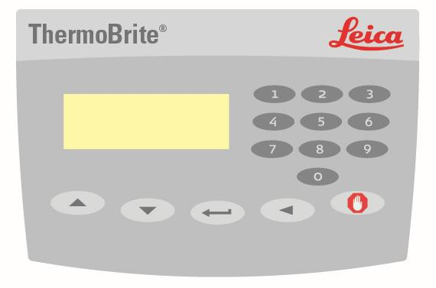

Keypad Symbols and Definitions
 | Up | Move cursor up; Enter character A-Z for program name
 | Down | Move cursor down; Enter character A-Z for program name
 | Enter | Accept or Enter
 | Backspace | Move cursor back to previous screen
 | Stop | End a program in process
8 | 0-9 | Enter numeric values for time and temperature or for program name

Display Abbreviations

Abbreviation | Expansion
PGM | Program
Denat & Hyb | Denaturation & Hybridization
Denat Temp | Denaturation Temperature
Denat Time | Denaturation Time
Hyb Temp | Hybridization Temperature
Hyb Time | Hybridization Time
Hyb Only | Hybridization Only
Fixed Temp/Fxd | Fixed Temperature

Audible Indicators - NORMAL

Single beep: | All legal keystrokes.
Two short beeps: | Upon accepting a field and cursor has moved to  next field.
Five beeps: | Completion of process.

Section 4

Operating Instructions

Opening and Closing the Lid
WARNING: The plate may be hot. Use caution and check temperature on display before handling slides. Improper precaution can cause a burn.
NOTE: Depressions located on either side of the lid allow user to simply lift lid into position. The lid should offer some resistance when opening. To close, reverse process. Assure front is completely down and no obstructions prevent the cover gasket from sealing on housing base.

Turning Unit On
The ThermoBrite main power switch is located on the rear panel. Assure unit is plugged into a grounded outlet. Move switch to ON (I) position. Instrument will beep to announce power has been turned on. Main Menu will be displayed when the instrument has reached the default temperature of 37°C.

Indicators on power switch: I=ON O=OFF

Run a PGM Edit a PGM Create a PGM
Present Temp: 37°C

Run a Program
Turn unit on and wait for the Main Menu screen. Cursor highlights “Run a PGM” line. Press “Enter” button to accept.
With the arrow keys, scroll through program numbers 1 to 40 / program names. Alternately, use the keypad to enter desired program number. If no programs have been saved advance to programming section of this handbook. To accept, press “Enter” button.
Enter PGM no. or Scroll (arrows)

PGM 01 namexxxxxx

Display will confirm PGM number, name, incubation time(s) and temperatures. Cursor highlights “Run PGM” line. Press “Enter” button to accept.

Hyb Only Denat & Hyb Fixed Temp

PGM 02 EBV | PGM 01 HER2 | PGM 03 BAKE
Hyb: 55°C 01:30 | 82°C :05; 45°C 20:00 | FIXED: 65°C
Run PGM | Run PGM | Run PGM
Main Menu | Main Menu | Main Menu
The display prompts to “Add Slides and Close Lid”. Before adding slides, saturate two Humidity Cards with distilled or deionized water, and insert into the inside lid. Now place the slides to instrument. (see Humidity Cards). Move cursor to highlight “Start” line. Press “Enter” button to run the program. To return to the Main Menu instead, move the cursor to highlight “Main Menu” line and then press the “Enter” button.

PGM 02 EBV | PGM 01 HER2 | PGM 03 BAKE
Add Slides – Close Lid | Add Slides – Close Lid | Add Slides – Close Lid
Start | Start | Start
Main Menu | Main Menu | Main Menu

15

Denaturation and Hybridization:
Display indicates present temperature of the slides.
PGM 01 HER2
**Heating** Denat: 82°C :05
Present Temp: 42°C

Once temperature reaches denaturation set point, the ThermoBrite will beep twice and denaturation time will count down from the set time.
PGM 01 HER2
Denat in Process Denat: 82°C 02:28
Present Temp: 82°C

The ThermoBrite will automatically cool to hybridization set temperature once denaturation is completed.
Please Wait

Cooling to Hyb 45°C Present Temp: 58°C

Hybridization time will count down from the set time once temperature reaches hybridization set point.
Upon program completion the ThermoBrite will beep five times and the display will show “PROCESS COMPLETE”. Hybridization temperature will be maintained until “End PGM/Main Menu” is accepted by pressing “Enter” button. Before pressing
“Enter” button, remove slides for further processing. If “End PGM/Main Menu” is not accepted within the first minute of program completion, the ThermoBrite will add the time accrued since completion of the original hybridization program to the time of the original hybridization program to give the Total Time at the hybridization temperature.

16
PGM 01 HER2 PROCESS COMPLETE
Total Hyb Time 21:05
End PGM/Main Menu

Hybridization Only:
Display indicates present temperature of the slides.
Please Wait

Heating to Hyb 55°C Present Temp: 45°C

Once temperature reaches hybridization set point, the ThermoBrite will count down from the set time.
PGM 02 EBV HYB
Hyb in Process 55°C 01:30
Present Temp: 55°C

Upon program completion the ThermoBrite will beep five times and the display will show “PROCESS COMPLETE”. Hybridization temperature will be maintained until “End PGM/Main Menu” is accepted by pressing “Enter” button. Before pressing “Enter” button, remove slides from instrument for further processing. If “End PGM/Main Menu” is not accepted within the first minute of program completion, the ThermoBrite will add the time accrued since completion of the original hybridization program to the time of the original hybridization program to give the Total Time at the hybridization temperature.
PGM 02 EBV PROCESS COMPLETE
Total Hyb Time 02:15
End PGM/Main Menu

Fixed Temp:
Display indicates present temperature of slides.
Please Wait

Heating to Fxd: 65°C Present Temp: 30°C
Once temperature reaches target, timer counts elapsed time.
PGM 03 APPL FIXED
Fixed Temp: 65°C
Reset Timer 01:18:10 End PGM/Main Menu

To end program, use the arrow keys to move to “End PGM/Main Menu” line and press “Enter” button to accept.
NOTE: If ambient temperature is programmed the fan will continually cycle until the program is aborted. The lowest temperature that may be programmed is ambient
+ 5°C or 30°C (whichever is higher).
NOTE: The temperature can be increased or decreased as the unit is running by using the up/down arrows from the “Fixed Temp” line.

Abort Program in Process
To end a program in process press “STOP” button, three beeps will sound.

Use arrows to move cursor to “Yes” line and press “Enter” button to accept. The program will continue to run until “Yes” or “No” has been accepted.
NOTE: The ThermoBrite prompts, “Are You Sure?” This measure is to prevent accidental disruption of a program in process.

ABORTING!
Are You Sure? No
Yes – Main Menu

Fan will turn on. If the slide temperature is above 37°C, the fan will cool to 37°C.

Slide Installation
Temperature uniformity across the heater is within 1°C of set point across all slide positions. The ThermoBrite allows up to a maximum of 12 slides to be installed.
When prompted simply lift the lid and load the slide(s) onto the plate. The frosted edge of the slides(s) should hang over the edge of the plate. Move the slide toward the middle of the plate by positioning the slide(s) into the slide separator.

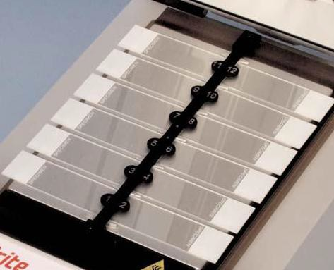
NOTE: Be sure the slide(s) rests flat on the heater plate before closing the lid or the lid may break slide(s).

Humidity Cards
Located in the lid, Humidity Cards act to prevent evaporation of probe mixture from prepared slides.

Instructions for use:
Saturate the Humidity Cards with distilled or deionized water (~13 mL for new cards).

Instructions for re-use:
- After the run has ended, keep the lid closed between runs to avoid drying out of the cards.
- Do not reuse cards that have been dried out after initial saturation.
- Resaturate the cards before starting a new run.
- The amount of water needed to resaturate the card depends on the program and the time in between runs.
- For each subsequent program, resaturate the cards with 3-10 mL to maintain moisture.
- Cards should be replaced every 1-2 weeks as they will deteriorate over time and with use.

Replacement instructions:
To replace cards, lift lid and remove. Slide card into slot positions and allow tabs in lid to support cards.
CAUTION: Do NOT use paper towels or any other filter card in card positions. This may change the humidity and may decrease the intensity of the probe, potentially causing assay failure.

Section 5

Programming

Overview
The ThermoBrite is capable of storing 40 different programs. Each program can be one of three program types:

- Denaturation and Hybridization (Denat & Hyb),
- Hybridization Only (Hyb Only) or
- Fixed Temperature (Fixed Temp).

Programming is simple. From the Main Screen, arrow down to “Create a PGM”, choose a program type and follow screen prompts to enter run times and set temperatures. The ThermoBrite maintains set temperatures for the duration of the protocol.

Select PGM Type Denat & Hyb Hyb Only
Fixed Temp
Run a PGM Edit a PGM Create a PGM
Present Temp: 37°C

NOTE: At the end of the program the display will show “Process Complete”. The temperature will be maintained and the timer will continue to run until End PGM/Main Menu is accepted by pressing “Enter” button.
NOTE: If all 40 program numbers have been used “Create a PGM” line in the Main Menu will no longer appear. An existing program must be edited, see “Editing a
Program”.

Predefined Limits

Program Mode | Temperature Range | Timer Limits
Denature | 50°C to 99°C | 00:00-00:30 minutes
Hybridization | Room temp: 30°C to 70°C | 00:00 - 99:59 hours and minutes
Fixed Temp | Room temp: 30°C to 99°C | 00:00 - 99:59 hours and minutes

Creating a Denaturation and Hybridization Program (Denat & Hyb)
From the Main Screen, use the arrow keys to move cursor to “Create a PGM” and press “Enter” button to accept.

Cursor highlights “Denat & Hyb” line; press “Enter” button to accept. The ThermoBrite will advance to the next available program number.

The ThermoBrite allows the user to create a program name. The cursor highlights the first name character position. Use the arrow keys to move through character set and press “Enter” button to accept the characters. All 10 character positions must be filled. Press “Enter” button to accept blank characters. For numeric characters use keypad 0-9.

Character set: A-Z; 0-9; period, - and blank (“Enter” button or move arrow)

The cursor will advance to “Denat Temp”. With numeric keypad enter a two-digit temperature value in degrees Celsius (50-99°C).

The cursor advances to “Denat Time”. With numeric keypad enter a two-digit time value in minutes (0 – 30).

The cursor advances to “Hyb Temp”. With numeric keypad enter a two-digit temperature value in degrees Celsius (30-70°C). The instrument allows a temperature of 30°C or ambient temp + 5°C (whichever is higher) for the lowest hybridization temperature.

For room temperature hybridization (ambient temp +5°C) enter the two-digit value 00.

The cursor advances to “Hyb Time”. With the numeric keypad enter a two-digit time value in hours (0 – 99) followed by a two-digit value in minutes (0-59).

The Display will now show entered program values. The cursor highlights “Enter to Accept” line.
Denat:
Hyb:
82°C :05
45°C 20:00
ENTER to Accept
STOP to Abort
Press “Enter” button to accept the program values; or press “Backspace” button to return to previous screen to modify program values; or press the “Stop” button to abort.

Creating a Hybridization Only Program (Hyb Only)

From the Main Screen, use the arrow keys to move cursor to “Create a PGM” and press “Enter” button to accept.

The cursor highlights “Hyb Only” line; press “Enter” button to accept. The ThermoBrite will advance to the next available program number.

The ThermoBrite allows the user to create a program name. The cursor highlights the first name character position. Use the arrow keys to move through character set and press “Enter” button to accept the characters. All ten character positions must be filled. Press “Enter” button to accept blank characters. For numeric characters use keypad 0-9.

Character set: A-Z; 0-9; period, - and blank (“Enter” button or move arrow).

The cursor advances to “Hyb Temp”. With numeric keypad enter a two-digit temperature value in degrees Celsius (30-70°C). The instrument allows a temperature of 30°C or ambient temperature + 5°C (whichever is higher) for the lowest hybridization temperature. For room temperature hybridization (ambient temperature +5°C) enter the two-digit value 00.

The cursor advances to “Hyb Time”. With the numeric keypad, enter a two-digit time value in hours (0 – 99) followed by a two-digit value in minutes (0-59).

The display will now show entered program values. The cursor highlights “Enter to Accept” line.
PGM 02 EBV
Hyb: 45°C 01:30
ENTER to Accept STOP to Abort
Press “ Enter” button to accept the program values; or press “Backspace” button to return to previous screen to modify program values; or press “Stop” button to abort.

Creating a Fixed Temperature Program (Fixed Temp)

From the Main Screen, use the arrow keys to move the cursor to “Create a PGM”
and press “Enter” button to accept.

With the arrow keys, move the cursor to “Fixed Temp” line and press “Enter” button to accept. The ThermoBrite will advance to the next available program number.

The display will now show entered program values. The cursor highlights “Enter to Accept” line.

The ThermoBrite allows the user to create a program name. The cursor highlights the first name character position. Use the arrow keys to move through character set and press “Enter” button to accept the characters. All 10 character positions must be filled. Press “Enter” button to accept blank characters. For numeric characters, use keypad 0-9.

Character set: A-Z; 0-9; period, - and blank (“Enter” button or move arrow).

The cursor advances to “Fixed Temp”. With numeric keypad, enter a two-digit temperature value in degrees Celsius (30-99°C). The instrument allows a temperature of 30°C or ambient temperature + 5°C (whichever is higher) for the lowest fixed temperature. For room temperature fixed (ambient temperature + 5°C) enter the two- digit value 00.

The display will now show entered program values. Cursor highlights “Enter to Accept” line.
PGM 03 APPL
Fixed: 65°C ENTER to Accept STOP to Abort
Press “Enter” button to accept the program values; or press “Backspace” button to return to previous screen to modify program values; or press “Stop” button to abort.

Editing a Program

From the Main Screen, use the arrow keys to move the cursor to “Edit a PGM” and press “Enter” button to accept.

With the arrow keys, scroll through the program numbers 1 to 40 / program names. If no programs have been saved, advance to programming section of this manual. To accept, press “Enter” button.
Enter PGM no. Or Scroll (arrows)

PGM 01 HER2

The cursor highlights existing program type: “Denat & Hyb”, “Hyb only” or “Fixed Temp”. Press “Enter” button to accept existing program type or use arrow keys to move the cursor to a different program type. Press “Enter” button to accept.

Use the numeric keypad to enter new values for Temperatures and/or Time. The procedure and limits are the same as those for creating a program.
NOTE: The ThermoBrite allows 40 programs to be entered and stored. Once all program numbers have been used, an existing program must be edited.

Section 6

Maintenance

Overview
Leica Biosystems recommends that instrument operators perform periodic inspections and maintenance on all Leica Biosystems instruments. Contact Leica Biosystems’s technical support department or distributor if, at any time, the instrument is not functioning properly. Contact Leica Biosystems’s technical support or distributor for more information.
WARNING: Unplug the ThermoBrite from the wall outlet before performing maintenance.

CAUTION: Do not expose the ThermoBrite to strong or concentrated acids, bases, esters, aromatic or halogenated hydrocarbons, ketones or strong oxidizing agents.

Cleaning

- The ThermoBrite is supplied with a removable slide separator.
- To remove, pull the separator back releasing the top from its holder (the separator is spring loaded to hold it in position).
- Lift the slide separator up and remove from spring holder at bottom.
- Set on the bench top.
- Clean the outside surfaces and switch overlay panel with a water-dampened cloth and mild detergent.
- Clean the inner surface with a mild detergent, and if necessary, a disinfectant, wiping surfaces with a dampened cloth using 70% alcohol or 10% bleach solution.

To replace a damaged or lost slide separator, contact customer service.

3801-004928-001 – Assy Separator
REF

CAUTION: Do NOT use harsh abrasives or scouring pads, this will scratch the heating surface.

Fan Filter
The fan filter, located on the underside of the ThermoBrite, should be removed from the ThermoBrite, rinsed with water and air-dried as needed. When dry, reinsert fan filter back into the underside of the ThermoBrite.

Temperature Verification
Leica Biosystems recommends users verify temperature of the ThermoBrite with the ThermoBrite Temperature Verification Kit. The ThermoBrite Temperature Verification Kit is available as an accessory to the ThermoBrite, and is purchased separately.

3800-006418-001 - ThermoBrite Temperature Verification Kit
REF
The ThermoBrite Verification Kit is a digital thermometer with a Type K thermocouple attached to a standard glass slide. Users should adhere to local guidelines for frequency of temperature verification.

Temperature Verification Kit Instructions For Use:
- Insert the battery per thermometer user guide to activate the digital thermometer.
- Insert the Type K thermocouple into T1 digital thermometer; be sure the +/- match up on both the meter and the thermocouple. Refer to the thermometer’s user guide for additional information.
- Insert two humidity cards into the ThermoBrite lid and saturate the cards with distilled/deionized water.
- Place the glass slide onto the ThermoBrite with the thermocouple facing up, making sure the glass slide is in full contact with the hot plate.
- Close the ThermoBrite cover.
- Turn on the digital thermometer by pressing the button with the red circle.
- Turn on the ThermoBrite and allow the ThermoBrite to warm up for 30 seconds.
- Set the ThermoBrite temperature to a fixed temperature.
- Once the fixed temperature is reached, wait up to 2 minutes for the temperature to equilibrate.
- Repeat steps 8 and 9 to measure different temperatures, if desired.
- The temperature readout on the digital thermometer should be within +/- 1˚C of the ThermoBrite display.

NOTE: The ThermoBrite Temperature Verification Kit’s digital thermometer should be recalibrated per manufacturer recomendations. Refer to thermometer’s user guide for more information.

Service

There are no user-serviceable parts except for fuses and the cover gasket. Refer all other service to technical support. Reference the Leica Biosystems Warranty for further instruction.

Decontamination is required before returning instrument for service
Any instrument or accessory containing accumulated blood and/or other biological or chemical deposits must be cleaned prior to shipment to the manufacturer/dealer for service. This decontamination is required by Federal Law (Title 48 and 49 of the Federal Regulations) and in accordance with the Environmental Protection Agency’s Regulations for Biohazard Waste Management. Leica personnel cannot perform this decontamination.

3801-004915-001 Fuse 3.0 A (120V)
REF
REF
3801-004915-002 Fuse 1.6A (240V)
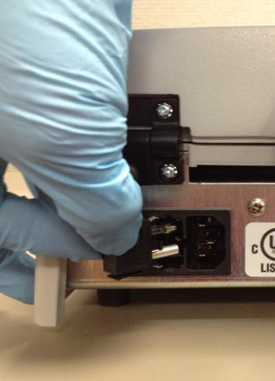
Fuses are located in the rear of the ThermoBrite between the main power plug and the On/Off switch.
Fuse Drawer Fuse(s)
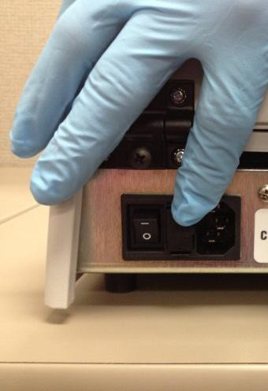
Fuse Replacement Instructions:
Unplug the ThermoBrite. Use a small flat screwdriver to carefully disengage the two snap-locks securing the fuse holder. Remove the fuse holder and inspect the type and value of the fuse. Replace existing fuse(s) with the same type and value. Insert the fuse drawer and push until two snaps are heard.
Cover Gasket:
REF
3801-004931-001 Cover Gasket
The cover gasket is located on the underside of the lid.
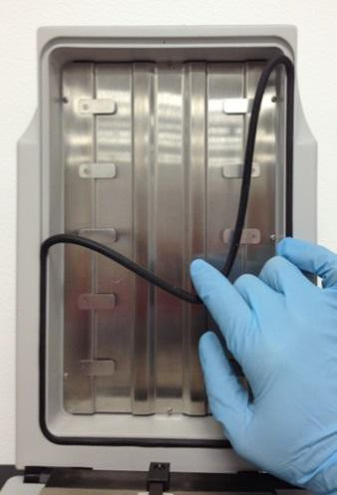
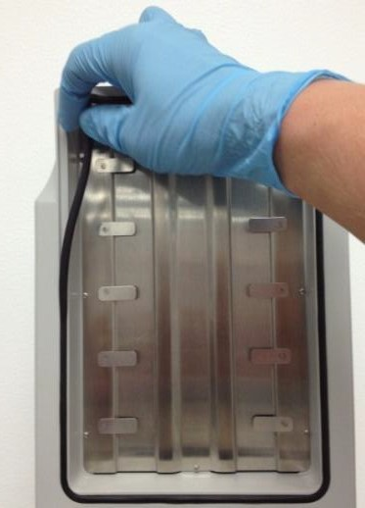
Cover Gasket Removal Cover Gasket Insertion

Cover Gasket Replacement Instructions:
Remove the existing cover gasket from the groove in the lid underside. Insert the new cover gasket with fingers. Be sure it is properly seated in the groove.
Troubleshooting Guide

Issue | Possible Cause/Remedy
Unit does not turn on or no power | Check both cord ends are plugged in
Unit does not turn on or no power | Check fuses located on rear panel next to On/Off switch If necessary, replace with same type and value (see label  on back of instrument)
Unit does not turn on or no power | If not resolved, contact technical support
Poor results on slides | Verify programmed protocol against probe manufacturer’s recommendation
Poor results on slides | Ensure Humidity Cards are in place and saturated with  distilled or deionized water
Poor results on slides | Humidity Cards should be replaced every 1-2 weeks as  cards cease retaining water
Poor results on slides | Verify the ThermoBrite is heating using the Temperature Verification Kit
Poor results on slides | Ensure lid is properly closed and verify that the cover  gasket seal is properly seated and free of damage
Poor results on slides | Ensure the ThermoBrite has the proper amount of  ventilation clearance
Poor results on slides | Ensure the fan filter is clean and free of debris
Poor results on slides | Ensure the plate is clean, allowing the slide full contact  with the plate
Temperature on display does not match surface temperature of slides | Clean the slide heating plate with 70% ethanol or 10% bleach; remove any sealant/rubber cement
 | Ensure the thermometer used to verify the temperature has current calibration
 | If not resolved, contact technical support

Issue | Possible Cause/Remedy
Cannot set temp above 70ºC | Verify the program mode, you cannot exceed preset limits
Cannot set temp above 70ºC | Denature Limits: 50-99°C, 00:00-00:30 minutes  Hybridization Limits: 30-70°C, 00:00-99:59 hours and minutes (Note: hotplate will hold 37°C after protocol end)  Fixed Temp Limits: 30-99°C, 00:00-99:59 hours and minutes
Can’t find “Create a  Program” | If the maximum of 40 programs have been stored, only an existing program can be edited.
Keypad not functioning  properly | Contact technical support
High temperature error | Ensure there is no obstruction of the fan on the underside of the  unit
High temperature error | Ensure the unit is positioned a minimum of 12” (30 cm) from the  wall
High temperature error | Ensure the ambient temperature is not greater than the lowest programmed temperature, + 5°C
High temperature error | If not resolved, contact technical support
Loose cover gasket | Ensure rubber cement/sealant is not causing cover gasket to  stick; clean and reinsert gasket
Loose cover gasket | Replace with a new cover gasket

Audible Indicators - ERROR

Three short beeps: | Entering of illegal or non-functioning keystrokes.
Low tone beep: | Attempt to enter a value out of acceptable range.
Continuous beep: | Instrument is not performing within acceptable range or program condition. Turn off main power and restart. If beep continues, discontinue use and contact technical support.
Error Messages
If the instrument cannot achieve a set temperature by heating within 10 minutes an error message appears to inform user to turn unit off and call service. A constant beep will sound.

SYSTEM ERROR! TURN UNIT OFF! CALL SERVICE

If the instrument cannot measure the temperature, the software will automatically turn off the heating. An error message will appear to inform the user to turn off the unit and call service. A constant beep will sound.

High ambient temperature condition:
The instrument will attempt to achieve process set temperatures. However, if the cooling fan cannot achieve the set temperature within 10 minutes, an error message will appear to inform the user that the ambient temperature is high. A constant beep will sound. The counter will continue to count. The present temperature will be displayed. Hitting the “Stop” button will allow the user to abort the process. A new screen will be displayed asking user if they are sure they want to abort.

For Hyb Only:
Please Wait Cooling to Hyb --°C Present Temp --°C
(“Ambient Temp High! Flashes alternately on this line)
For Fixed Only:
Please Wait Cooling to Fxd --°C Present Temp --°C
(“Ambient Temp High! Flashes alternately on this line)

Abort Screen Message:
ABORTING!
Are You Sure? No
Yes – Main Menu

If the ambient temperature changes during a process and causes the instrument process set temperature to change beyond the +/- 1°C specification for more than two minutes, a message will appear to inform the user that the ambient temperature is high. A constant beep will sound. The counter will continue to count. The present temperature will be displayed. Hitting the “Stop” button will allow user to abort the process. A new screen will be displayed asking user if they are sure they want to abort.
For Hyb Only:
PGM – namexxxxxx
Hyb In Process (“Ambient Temp High!” flashes alternately on this line)
Hyb--°C --:--
Present Temp: --°C

For Fixed Only:
PGM – namexxxxxx
Fxd Temp --°C (“Ambient Temp High!” flashes alternately on this line)
Reset Timer 00:00:00 End PGM/Main Menu

Abort Screen Message:
ABORTING!
Are You Sure? No
Yes – Main Menu

If the ambient temperature changes after a process is completed, but before the user removes the slides and causes the instrument process set temperature to change beyond the +/- 1°C specification for more than two minutes a message will appear to inform the user that the ambient temperature is high. A constant beep will sound. The counter will continue to count. The present temperature will be displayed. Hitting the “Stop” button will allow user to abort the process. A new screen will be displayed asking user if they are sure they want to abort.
For Hyb Only:
PGM – namexxxxx
PROCESS COMPLETE (“Ambient
Temp High!” flashes alternately on this line)
Total Hyb Time --:--
End PGM/Main Menu

Abort Screen Message:
ABORTING!
Are You Sure? No
Yes – Main Menu
NOTE: If 40 programs have been created or edited the software will blank out the “Create a PGM” mode on the main menu screen. This will only allow users to edit existing programs.
Run a PGM Edit a PGM

Present Temp:--°C

Section 7

Specifications

Product No. | 3800-004852-001 | 3800-004852-002
Model No. | S500-12 | S500-24
Capacity | Up to 12 slides
Temperature Range | 30°C -99°C  Lowest programmable temperature is 30°C or ambient temperature+5°C (whichever is higher)
Processing Time | 00:00 - 99:59 hr:min
Number of Programs | 40
Ramp Time | 37-95°C in less than 3 minutes
Cooling Time | 95-45°C in less than 6 minutes
Electrical | 120 VAC 50/60 Hz @ 3.0 A | 240 VAC 50/60 Hz @ 1.6 A
Dimensions | Depth 45.1 cm/17.8 in Width 22.8 cm/9.0 in Height 13.5 cm/5.3 in Weight 6.5 kg/14.3 lb
Environmental | Indoor Use
Environmental | Altitude up to 2000m
Environmental | Temperature 15°C to 40°C
Environmental | Maximum relative humidity 80% for temperatures up to 15°C decreasing linearly to 50% relative humidity at 40°C
Environmental | Main supply voltage fluctuations not to exceed +/- 10% of the nominal voltage transient over-voltages according to installation category II Pollution degree 2

Biohazard References
  - NCCLS. “Protection of Laboratory Workers from Occupationally Acquired Infections; Approved Guideline-Second Edition.” NCCLS document M29- A2 [ISBN 1-56238-453-8]. NCCLS, 940 West Valley Rd, Suite 1400, Wayne, Pennsylvania 19087-1898 USA, 2001.
  - CDC. Recommendations for prevention of HIV transmission in health care settings. MMWR (Suppl. No. 2S):2S-18S, 1987.
  - CDC. Updated: US Public Health Service Guidelines for the Management of Occupational Exposures to HBV, HCV and HIV and Recommendations for Post Exposure Prophylaxis. Appendix A and B. MMWR 50 (RR-11): 1- 42, June 29, 2001.
  - NCCLS. Fluorescence in situ Hybridization (FISH) Methods for Genetics; Approved Guideline. NCCLS document MM7-A (ISBN 1-56238-524-0). NCCLS, 940 West Valley Road, Suite 1400, Wayne, Pennsylvania 19087- 1898 USA, 2004.

INDEX

A
Abort program in progress 18 Adding slides to module 15 Alerts 3 Audible indicators ERROR 31 Audible indicators NORMAL 13 Authorized European representative 6 B
Biological warnings 4, 5
C
Cautions 3 Cleaning 26 Cleaning instrument surfaces 26 Closing the lid 14, 19 Contact information Leica Biosystems 6 Contents 1,2 Creating a denaturation and hybridization
program (Denat & Hyb) 22 Creating a hybridization only
program (Hyb only) 23 Creating a fixed temperature
program (Fixed temp) 24
D
Definitions 5 Discarding liquid waste 28 Disclaimer of warranty 8 Display abbreviations 13 E
Editing a program 25 Electrical connections 10 Electrical requirements 10 Error messages 31 F-G
Fuses, replace 29
H
How to use this manual 3 Humidity cards 19
I-J-K
Keypad 11 Keypad symbols and definitions 12 Incubate 15 Inspect packaging 9 Installation 9 Installation instructions 9 L
Leica Biosystems contact information 6 Leica Biosystems warranty 7
M-N
Maintenance overview 26 Manufacturer 6
O
Opening the lid 14
Operating instructions 14 Operator’s manual, how to use 3
P-Q
Power port 10 Power switch 14 Precautions 3 Precautions and safety 3 Principle and intended use 11 Product support 6 Programming overview 21 Programming predefined limits 22 R
References 36 Replacing the fuses 29 Run a program 15

S
Safety 3 Selecting a protocol to run 15 Service 28 Slide carriers 19 Slide installation 19 Specifications 35 Symbols 5 System overview 11
T
Temp 16 Temperature requirements 16 Temperature verification 27 Troubleshooting guide 30 Troubleshooting by symptoms 30 Turning unit on 14
U-V
Unpacking 9 Verify contents 9
W-X-Y-Z
Warnings 3 Warranty 7

Manufacturer
Leica Biosystems Richmond, Inc. 5205 Route 12
Richmond, IL 60071 USA


AR Experts B.V.
Boeingavenue 209
1119 PD Schiphol – Rijk,
The Netherlands

